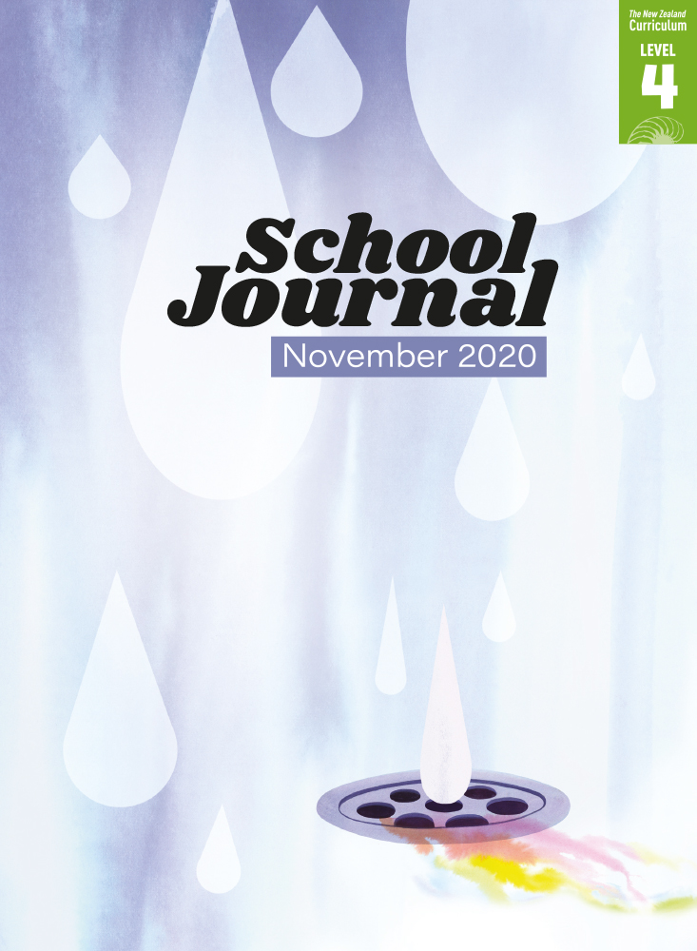

School Journal

Level 4, November 2020

**Year 8**

# Journeys of Discovery: The Life of Alfred Wallace

by Paul Mason

The[Learning Progression Frameworks](https://curriculumprogresstools.education.govt.nz/lpf-tool/) describe significant signposts in reading and writing as students develop and apply their literacy knowledge and skills with increasing expertise from school entry to the end of year 10.

## Overview

The naturalist Alfred Wallace and his close association with the theory of evolution is little known – most people think of Charles Darwin. Yet Wallace’s story is a classic one of adventure, talent, and persistence before he was able to offer one of the most ground-breaking scientific theories of all time. Most readers are exposed to the work of scientists in the present day; the nineteenth-century setting of this text is an excellent way to broaden their understanding of how scientists have increased their understanding of the world over time and the major milestones along the way. This article is designed to be read alongside the fictional story “Dodinga, 1858”, written by the same author.

A PDF of the text is available at [www.schooljournal.tki.org.nz](http://www.schooljournal.tki.org.nz)

## Themes

|  |  |  |  |
| --- | --- | --- | --- |
| * Evolution | * Scientific discovery | * Persistence and passion | * Solving scientific problems |

## Related texts

**“Dodinga, 1858”** SJ L4 Nov 2020 | **“Rongoā for the Land”** SJ L4 Nov 2020 | **“Richard Owen’s Giant Mystery”** SJ L3 Aug 2015 | **“The Coprolite Hunters”** SJ L3 Nov 2020

## Strengthening reading behaviours (what to notice)

|  |  |
| --- | --- |
| Text structure and features | Requiring students to: |
| * Metaphor and figurative or connotative language *family fell on tough times*; *the book caused an uproar*; *divine power*; *feel the pulse* * Technical information *It was almost as if imaginary lines divided species into groups.  Wallace had reached an important conclusion: species were most closely related to others not only near them in space but also in time.* * Additional information The text box about Victorians | * integrate their knowledge of figurative language and its purpose with the context to interpret and infer meanings and build a picture of Wallace’s life and the events that are referenced in the article * carefully track the ideas, evolving findings, and examples described in the text to understand Wallace’s theory and how he came to develop it (Rereading, organising, asking questions and summarising will help to consolidate understanding.) * differentiate between key ideas and those that are interesting and add detail but don’t affect the key ideas. |

|  |  |
| --- | --- |
| Vocabulary | |
| Scientific names of species  Other possibly challenging words | *Ornithoptera croesus*, *Megachile pluto*  malaria, specimen, racks, species, memoir, naturalist, expedition, unique, exotic, origin, archipelago, characteristics, incrementally, mechanism, evolutionary, camouflage, originated, diminish, tendency, indefinitely, natural selection, theories, acquaintance, eminent, spiritualism, apprehension, regulated, retreated, consumed, flourish, indescribable, intense |

|  |
| --- |
| Helpful prior knowledge (pre-reading and introducing the text) |
| * That all species are a part of the same system of taxonomy, with each one classified and named – but scientists didn’t have a clear understanding of why and how species evolved until the mid-nineteenth century * Charles Darwin is credited with developing the theory of evolution of the species. |

## Possible reading and writing purposes

* Find out about a little known 19th-century scientist who made an amazing discovery
* Identify and describe Alfred Wallace’s contribution to the theory of evolution
* Describe the qualities Alfred Wallace portrayed during his life’s work
* Evaluate the writer’s purpose in telling this story.

See *Effective Literacy Practice in Years 5–8* for information about teaching comprehension strategies ([Teaching comprehension](https://literacyonline.tki.org.nz/Literacy-Online/Planning-for-my-students-needs/Effective-Literacy-Practice-Years-5-8/Teaching-comprehension))   
and for suggestions on using this text with your students ([Approaches to teaching reading](https://literacyonline.tki.org.nz/Literacy-Online/Planning-for-my-students-needs/Effective-Literacy-Practice-Years-5-8/Approaches-to-teaching-reading)).

## Possible curriculum contexts

This text has links to level 4 of *The New Zealand Curriculum* in: [**ENGLISH**](http://nzcurriculum.tki.org.nz/The-New-Zealand-Curriculum/English) [**SCIENCE**](https://nzcurriculum.tki.org.nz/The-New-Zealand-Curriculum/Science)

## Understanding progress

The following aspects of progress are taken from the [Learning Progression Framework](https://curriculumprogresstools.education.govt.nz/lpf-tool/)s and relate to the specific learning tasks below. See the LPFs for more about how students develop expertise and make progress in these aspects:

* Acquiring and using information and ideas in informational texts
* Making sense of text: using a processing system; using knowledge of text structure and features; vocabulary knowledge; reading critically
* Using writing to think and organise for learning.

## Strengthening understanding through reading and writing

**Select from the following suggestions and adapt them** according to your students’ strengths, needs, and experiences.   
Note: Most of these activities lend themselves to students working in pairs or small groups.

* Share the first reading purpose. Prompt the students to share their initial reactions. *What was something you found interesting? What was amazing? If you were Wallace, how would you react to what Darwin did? Was it fair? Would you choose to be a scientist in Victorian times?* Make connections with aspects of the story such as the hardships and challenges Wallace faced.
* Remind the students that good readers ask questions as they read to gain deeper meaning from the text. Ask them to think back to questions they had as they read. Prompt them by modelling, for example: *When I read about Wallace travelling to Brazil, I wondered how he got there and how long it took in 1848.* Have them discuss how their questions helped to better understand the key ideas and information.
* To support the students to integrate and synthesise new information across the text, have them complete the **Building information 5Ws & H** template at the end of this TSM. (This is a useful way to develop note-taking skills.)
* Discuss what life was like in the Victorian era. Ask the students to find evidence in the text about life in this period, for example, how people travelled and how important information and new discoveries were shared.
* Have the students explore what Alfred Wallace was like as a person. *Wallace went out to work at age 14 ­– what might have been the reasons he left school? What qualities did he show? Find words and phrases the author used to describe him. What was he interested in? What was he trying to prove?* Ask the students to write a summary statement about what Wallace was like.
* Review the use of metaphor and figurative or connotative language. Talk about how it’s a writing technique used to support the meaning by creating a feeling of what happened or making it easier to visualise. Ask the students to find examples in the text and discuss what each one means. (See Text structure and features on page 1 of this TSM for some examples.)
* Explore the structure of the text, focusing on the headings. Have the students record each heading and analyse the information in each section. Encourage them to consider the purpose and effectiveness of the heading and its relevance to the information in that section.
* Give the students stickies and ask them to identify any new or challenging words in the text. They could use a graphic organiser to develop their understanding of the words, for example, the Frayer Model (“[Don’t Forget to Vote](https://instructionalseries.tki.org.nz/)” TSM SJ L2 Nov 2020) or the Exploring Words and Phrases template (“[Want Relief](https://instructionalseries.tki.org.nz/Instructional-Series/School-Journal/School-Journal-Level-3-May-2020/Want-Relief)” TSM SJ L3 May 2020).
* Discuss what the writer wants us to think about Wallace. *Why do you think this? How does he do it?* Ask the students to find evidence in the text to support what they say.
* Have the students draw a T-chart about Wallace and evolution labelled Prior knowledge (What I already knew) and New information (What I learnt from the text). Underneath, have them write a sentence or paragraph synthesising their knowledge labelled My new understanding.
* The students could think of questions they would like to ask Wallace and then play Hot Seat, with one student taking the role of Wallace and others in the group asking questions.

|  |
| --- |
| “Journeys of Discovery: The Life of Alfred Wallace”  Building information 5Ws & H |

Building knowledge about something new as you read.

* In the left-hand column, write what you learnt from the introduction.
* Underneath, write any questions you have after reading the introduction. Add to these as you read.
* Add short notes about any information you find out as you read. Record the page number so you can find the information again easily.

|  |  |  |
| --- | --- | --- |
|  | From the introduction | Information that is built across the text  (Record page numbers and brief notes) |
| Who |  |  |
| What |  |  |
| When |  |  |
| Where |  |  |
| Why |  |  |
| How |  |  |

Questions I have as I read: